**Project Design Phase-II**

**Data Flow Diagram & User Stories**

| Date | 31 January 2025 |
| --- | --- |
| Team ID | SWTID1742572631 |
| Project Name | Movie Ticket Booking System |
| Maximum Marks | 4 Marks |

**Data Flow Diagrams:**

A Data Flow Diagram (DFD) is a traditional visual representation of the information flows within a system. A neat and clear DFD can depict the right amount of the system requirement graphically. It shows how data enters and leaves the system, what changes the information, and where data is stored.

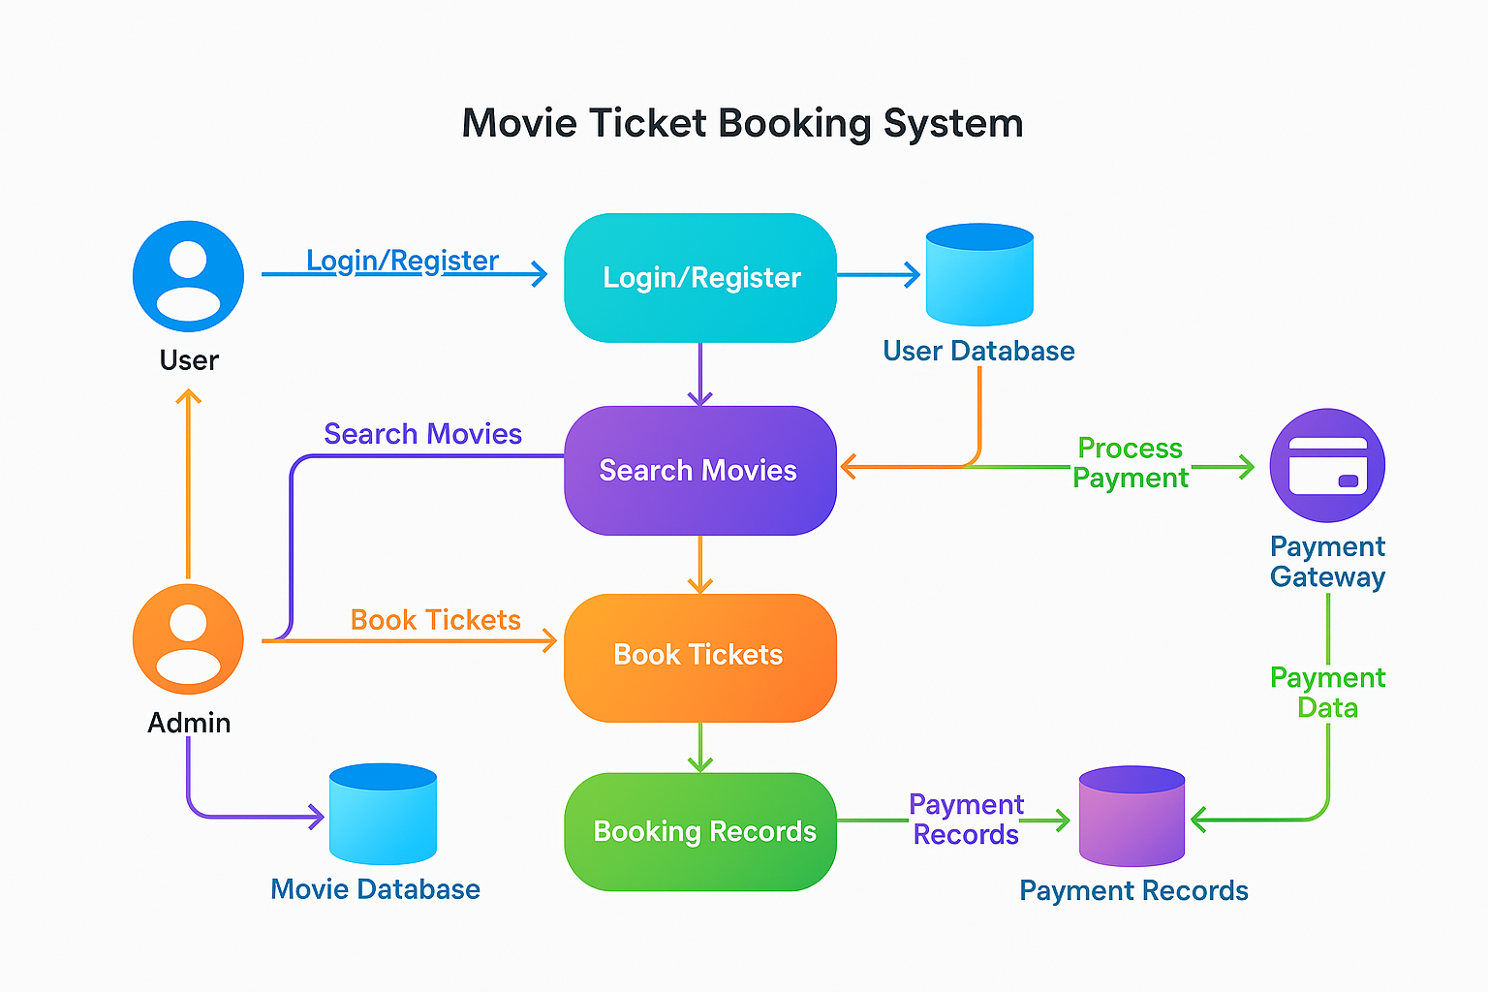

Fig 1 : Easy simpler to understand Data Flow Diagram

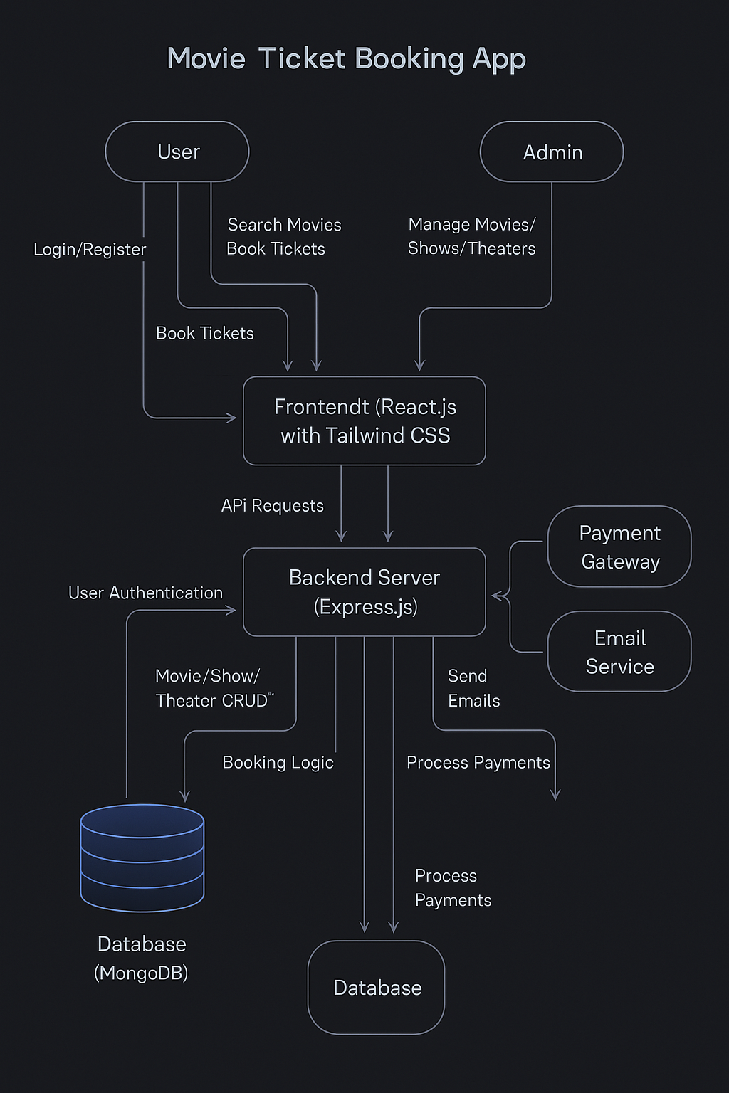

Fig 2 : Data Flow Diagram

**User Stories**

Use the below template to list all the user stories for the product

| **User Type** | **Functional Requirement (Epic)** | **User Story Number** | **User Story / Task** | **Acceptance criteria** | **Priority** | **Release** |
| --- | --- | --- | --- | --- | --- | --- |
| Customer (Mobile user) | Registration | USN-1 | As a user, I can register by entering my email, phone number, and password | I can access my profile/dashboard | High | Sprint-1 |
|  |  | USN-2 | As a user, I receive a verification email/SMS after registering | I receive and click the verification link | High | Sprint-1 |
|  | Login | USN-3 | As a user, I can log in using my email and password | I am redirected to the homepage | High | Sprint-1 |
|  | Browse Movies | USN-4 | As a user, I can view a list of currently running and upcoming movies | I can see movies by city/date/language | High | Sprint-1 |
|  | Book Tickets | USN-5 | As a user, I can select a movie, showtime, and seats to book tickets | I can successfully book and see a confirmation screen | High | Sprint-2 |
|  | Payment | USN-6 | As a user, I can make payment through UPI/Credit Card/Wallet | I get a payment success message & ticket is emailed | High | Sprint-2 |
|  | Cancel Booking | USN-7 | As a user, I can cancel my booking before the showtime | I get refund confirmation and cancellation message | Medium | Sprint-3 |
| Customer (Web user) | Login | USN-8 | As a web user, I can log in using Google/Facebook | I can access my dashboard via social login | Medium | Sprint-1 |
|  | View Booking History | USN-9 | As a user, I can view my past and upcoming bookings | I see list of bookings with status | Medium | Sprint-2 |
| Customer Care Executive | Manage Complaints | USN-10 | As a care executive, I can view and respond to customer complaints | I can resolve and close complaint tickets | High | Sprint-3 |
| Administrator | Add/Manage Movies | USN-11 | As an admin, I can add, edit, or remove movie details | Movies are visible/updated for users | High | Sprint-1 |
|  | Add/Manage Showtimes | USN-12 | As an admin, I can schedule and manage showtimes for theaters | Showtimes are updated and available for booking | High | Sprint-1 |
|  | Manage Users | USN-13 | As an admin, I can view user data and deactivate accounts if needed | Users can be managed from admin panel | Medium | Sprint-2 |